CALLBACK HELL//or PERAMID OF DOOM

When the code fails to run we are using a method called “sendEmergencyMessageToCeo()”

## Inversion of Control

Ek function ko dosray function ko de dena blindly trust krna, jo ander function hum de rhy aka callbackFunction us ka poora control hum de rhy hian yeh ek setback hai callbackFunctions ka

## Pyramid of doom

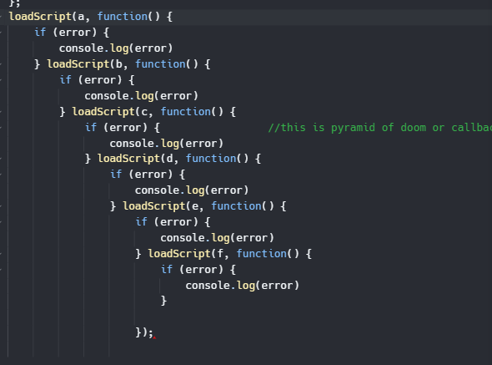

<https://replit.com/@Hasnain150/callBacks30#script.js>

<https://youtu.be/fIPJUteOdLc>